**MINOR PROJECT-II REPORT**

**On**

**IOT BASED IRRIGATION SYSTEM**

## Submitted by:

|  |  |  |  |
| --- | --- | --- | --- |
| **Name** | **Roll No** | **Branch** | **SAP ID** |
| Mayank Rajput | 26 | BCAIOT | 500076142 |

**Under the guidance of**

## Dr. Rohit Srivastava



### SCHOOL OF COMPUTER SCIENCE

UNIVERSITY OF PETROLEUM & ENERGY STUDIES

Bidholi Campus ,Energy Acres,Dehradun–248007.

### April-2022



**School of Computer Science**

**University of Petroleum & Energy Studies , Dehradun**

### Project Proposal Approval Form (2019-2022)

**Minor**

II

**PROJECT TITLE:** IOT Based Irrigation System

# 1.Abstract

IOT(internet of things) is described as a technology that can be used to increase digitalization in any field like, Business, home automation , automatic farming ,etc.

We can bring automation into farming and make it digitalized by using IOT. We can transform our farming from being static and manual to an excellent and outstanding system that will reduce the percentage of human intervention in farming. Through this project we present you an automated IOT based irrigationsystem which controls andmaintainsthe suitable soilmoisture content through automatically supplying the water to the crops. Microcontroller ATMEGA328Pon arduino uno device is used to control the IOT based irrigation system.This system is consists of soil moisture sensors which measures the approx soilmoisture level in soil. The value which we get from sensor allows us to use the appropriate amount of water which helps in reduction of water wastage. We use IOT so that the farmers can keep an update on how the supply of water is going into the filed.

As we all know that we are wasting water everyday knowing that it is a limited resource and if we use it excessively then our upcoming generations are going to face problem in getting this natural resource.**Agriculture accounts for around 70% of all water withdrawals globally according to the World Bank, and approximately 60% of that is wasted, largely due to inefficient applications according to the UN’s Food and Agriculture Organization (FAO).**(1)

**In India where we have more than 50 % of population which make their living on farming so, we can say in India we have a large number of farmers. We are also wasting water in irrigating our fields and we are ending the limited resource of water.**

**We are going to develop a IOT based Irrigation System to conquer this problem of wasting water during irrigation. By using this system farmers can irrigate their fields according to what amount of water is required by soil and will not provide excess amount of water , In this way we can irrigate our fields and at the same time we can save the water which earlier we were wasting and help our coming generations so, that they can also freely use the water as we are using it.**

**In this project we are going to use following devices we will learn about these devices later :-**

**1-Arduino Uno kit**

**2-Water pump**

**3- 4-Relay motor board**

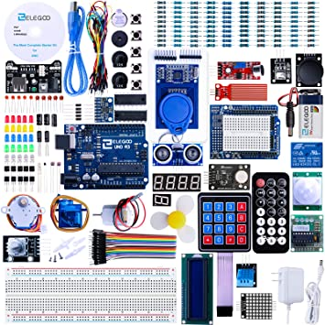

**Figure1**

**Arduino Kit**(2)

# Index

|  |  |  |
| --- | --- | --- |
| **S.No.** | **Title** | **Page Number** |
| 1. | Abstract  1.1 Abstract | 2-3  3 |
| 2. | Introduction  2.1 Sprinkler system  2.2 Drip System  2.3 Surface System  2.4 Basin System  2.5 Furrow system | 6-8  6  7  7  8  8 |
| 3. | Literature Review  3.1 Automated Irrigation system  3.1.1. Soil Moisture Sensor  3.2.1Arduino Microcontroller  3.3.1 4-Relay Module | 9-10  9  9  10  10 |
| 4. | Problem Statement | 11 |
| 5. | Objectives | 12 |
| 6. | Design and Methodology  6.1Proposed System  6.2 Flow chart  6.3 Block Diagram  6.4 Circuit Diagram  6.5 System Requirments | 13-17  13  14  15  15  16  17 |
| 7.  8.    9.  10. | Prototype  Arduino Platform code  Conclusion and Future  Scope  References | 18-19  20-21  22  23 |

**2.Introduction**

Irrigation is a process of irrigating our crops and making them fertilize so that we can grow food in this process water is carried out to the fields through pipes and sprinklers. By using this process we can easily deal with the drought like situations. Due to sudden changes in the climate, we cannot rely on natural sources of water. Irrigation is very important to grow good quality food in the seasonable or non-seasonable period**.**

To move towards [modern agriculture](https://dipslab.com/precision-farming/) we need a smart irrigation system to reduce the human intervention and increase the output and decrease the time taken to irrigate the fields . It is one of the best technology used all over the world to yield crops , In some hilly parts of India, Nepal, China terrace farming is used in this type of farming water is run over the fields that are in the form of stairs so it flows down the stairs irrigating every field we can use smart irrigation system as we know how hard it is to find water on mountains it will increase the annual crop cultivation in these areas and now because of smart irrigation system they can grow crops which uses more water it will also help them to develop their economy and will make their financial conditions good . it is very easy to understand this system anyone can use it irrespective of gender or qualification or knowledge it is very cheap and easy to use as most of the farmers are not well qualified in studies so they can also understand it and use it without facing any problem.

Through this paper we can learn how we can setup and use sensors and other IOT devices and how we can use their data to control irrigation system .

While planning for irrigation some primary points that need to be considered are:-

1. We need to check whether the land is suitable or not for the crop.
2. We need to check that it is going to rain or we need to irrigate the filed by ourselves.
3. We need to check the conditions responsible for growing crops and decide when it is best to irrigate the fields.
4. The amount of water required by the crops during irrigation.
5. For irrigation we need to select the best irrigating method among various methods.
6. We need to check the water quality index so that we an assure that the water we are using is good for crops.

In India there are more than 50% of population is living on farming so, in India we uses different techniques to irrigate our fields according to farmers , climatic conditions and specific areas . Basically in India we use five main methods of irrigation that are as follows:-

1. Sprinkler System
2. Drip System
3. Surface System
4. Basin System
5. Furrow System

**2.1 Sprinkler System:-**

* It is kind of in resemblance with the rain .
* It reaches the ground by using sprinkler heads.
* We can apply this system on all types of soils because of the wide varieties of sprinklers present in market.

**2.2 Drip System:-**

* In this method water comes down slowly from the pipes to enter the roots of the plants.
* Sometimes it is also called micro-irrigation, we can save both soil nutrients and water by using it.Valves , tubes ,emitters and pipes are used in this method.
* We can use a controller to operate it we can decide whether we want to operate it manually or automatically .

**2.3 Surface System:-**

* We are using this method from decades.
* In this technique water is spilled over the ground so that it can react to the plants .
* In this method we flood the fields or we fed the water into small channels.

**2.4 Basin System:-**

* It is mainly used in agriculture fields that require huge amount of water than usual crops like rice, etc.
* In this method fields are surrounded by bunds to hold the water inside the field so that it cannot enter the fields that are touching its boundary.
* We are able to grow trees using this irrigation system.

**2.5 Furrow System:-**

* In this technique water is carried through small channels to down the slopes and the crop rows.
* It is useful to put crops in a line and the crops that are not capable of irrigating the water.
* It must determine which type of soil is used, what size of the stream we will need, what should be the depth of the irrigation.

In India agriculture is undoubtedly the largest livelihood in India. As we see a rise in population in India we need more production in the field of agriculture so that we can feed our people without any shortage of food. If we want to increase the agricultural production then we are going to need more fresh water for irrigation. Currently agriculture accounts 83% of the total water consumption in India.(3) If we are not going to manage how to use water properly it will result in wastage of water.

To solve this problem we urgently need to develop systems that can help farmers without wasting the water and without applying force on farmers.From last 15 years farmers has been using electronic devices to keep track of their financial accounts, farmers are also keeping a track of their trade and investments with the IIIrd party and they have been monitoring their crops too. We are living in an internet era and in this era information is the key to success in any field agriculture is speedily growing into a big and large data intensive industry where farmers are going to collect and illustrate a large piece of information from various electronic and digital devices so, they can gain more efficiency in production and getting the correct information.

By using microcontroller Arduino uno board along side with. Low cost soil moisture sensors, it is possible to create useful devices that can keep an eye on the soil moisture content and according to that data it can irrigate the fields when needed to be. This proposed system contains a Microcontroller Arduino Uno Board, a arduino platform software to upload the code in to the board and sensors to check the moisture of the soil surface and enables farmer can watch the conditions of pipes that are being installed on fields by knowing the values that are sent by the sensors thus, allowing farmers to less concentrate about the irrigation and focus on other major filed works to perform freely.

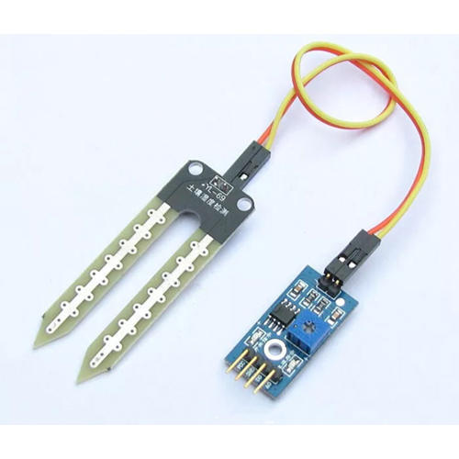

**Figure 2**(4)

Soil Moisture Sensor

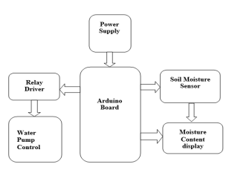

**Figure 3** (11)

BlockDiagram

This proposed system consists of hardware and software elements. The hardware part is made up of embedded systems and the software part consists of an arduino platform to write your code compile and test it and then upload it into your arduino board the name of the platform is aruino.ink it is available online as a free and open source software.When the soilmoisture is down the sensor module sends a signal that turns the water pipe on. Sensors show both outputs digitalized and normal .We can use advanced output easily to utilize however isn't so exact as the simple result. As the microcontroller used for the Arduino Uno contains a easily available 10-cycle 6-channel simple to-advanced (A/D) converter, the simple information pin of Arduino can scan the simple signals sent by the sensor and return parallel numbers from 0 to 1023.

Greateramount of output implies lesser moisture content.

The objective of this system is to reduce the water wastage and help the farmers in managing the water supply through pipes, sprinklers, etc.

# 3.Literature review

**3.1 Irrigation system :**

This automatic system consists of arduino and sensors to optimize the need of water . To control current flow in our circuit we used 4-Relay Board in this system to control the water pump and divide the current. Arduino takes action according to the signals sent by the soil moisture sensors and accordingly controls the water supply. Once the signal is received by the arduino board then it reads the signal and transfer the command to the 4-relay board then the 4-relay board sends the command to the water pump and then it on/off according to the command sent by the micro controller. Arduino controls the system in a suitable way .To Upload code in the Arduino we use Arduino IDE and then You have to select in which port your Arduino Boarrd is connected to your laptop then you have to select the language you are going to write code and then you have to compile it .If it is compiled successfully then you can use the save option and then you can upload it into your Arduino Board.

**3.1.1. Soil Moisture Sensor :**

Soil moisture sensor plays a immense role in this project .Soil moisture sensor sense the amount of water in the soil since we human’s don’t observe the moisture level in the soil that’s why we used Soil moisture sensor in this project .Use of this sensor is very simple we just have to dip two nails of this sensor into the soil.The sensors sends the signals with the help of this nails it gives range of number in output from 0 to 1023.(7)

Also we can control the sensing power of this sensor with the help of potentiometer(it is a adjustable voltage divider) .Potentiometer is also install in fan regulators .



Figure 3.1.1

Soil Moisture Sensor (4)

**3.2.1Arduino Microcontroller:**

Arduino is an open source platform. If you have to create any project related to IOT you have to know about

Arduino first .Arduino is based on easy to use hardware and software.Arduino have Atmega328 , 6 analog and

14 digital pins on board.Arduino is used to give input to the sensors .You can write program easily in arduino

IDE if you have learned java and c++ because there Systax are same .

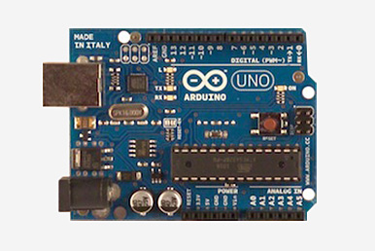

Figure 3.2.1(8)

Arduino Microcontroller

**3.3.1 4-Relay Board:**

Relay board is used to control high level voltage like we used this in our project to control warte pump as water

Pump need high voltage .It is not programmable but we can write condition to control the relay . Relay is used with microcontroller we have connect this board with Arduino with the help of wires and when the condition encounter arduino send signal to relay wether pump have to on/off.(10)

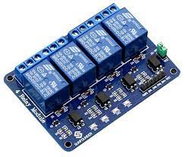

Figure 3.3.1 (10)

4-Channel 5V Relay Module

# 4.Problem Statement

Agriculture plays very significant role in india GDP year by year it will increases agricultural production , according to report 2020-2021 it will increases upto 19 percent .In agriculture more water is consumed than the rainfall . Improvingfarm yield is essential to meet the rapidly growing demand of food forpopulation growth across the world .In an automatic irrigation system is required so that we can optimize water use for agricultural crops.The technique can beused for application of accurate amount of water. By forming sensornetwork, good monitoring of waterregulation in the agriculture field can beachieved. Advanced tools and technology can be used to increase farmyield. The microcontroller Arduino controls relay unit andwatering system of irrigation system.(5)

To date most farmers have been usingconventional farming irrigation techniques.Particularly for paddy, where they use a techniqueknown as flood irrigation in which water is leftstanding during the growing season. Nearly 50%of the water percolates into the soil and another20% evaporates and the remaining 30% is what the  
crop needs. This paper focuses primarily onaddressing the problem of over-irrigation, under-irrigation and manual labour. In addition it savesthe farmer's time, money and electric energy.Knowledge in electronics and computing has beenused in recent years to solve most of the challengesin agriculture.

Nowadays farmers facing a lot of problem in agricultural field due tono proper water resources(irregular rainfall). To overcome this problem many irrigationsystem are made which we discuss above . And there is one more problem in agriculture is that sometime water is standby inthe field and it will damage the crops , due to overwatering into the field this happen or by huge rainfall this happen so, we can’t control the natural thingbut we solve the problem of overwatering .we need to manage the water resources

We also come up with a solution of this problem that will really help the farmer to overcome this

Problem.We make an IOT based irrigation system this system is automatic there is no human

intervention Once the system is installed sensors or pumps do there work. Through this system

wastage of waterArduino(microcontroller) and then arduino process this senses value with a

conditionsOutput of this condition comes in High/Low value . This High/Low signal is send to

the relay and then relay give signal to pump whether it have to perform action or not.

# 5.Objective

To generate a system, that will make the existing irrigation system more reliable and with less human intervention and less man-power. The main purpose of project is to provide farmers with automatically operating motor for irrigation depending upon the moisture value of soil.

1. **Reduce human intervention:** As all the work done through sensors the work can be done easily and it will reduce the human intervention.
2. **Avoid Wastage:** In traditional system Indian agriculture depended on the climate and rainfall it does not provide enough water resources ,this automatic system is implemented to provide water to plants according to their moisture level.
3. **Design And Methodology**

**6.1 Proposed Statement :**

Scarcity of water is the major issue that no country wants to face in future. And as Agriculture is one of the most important sectors that uses a large amount of water in India therefore various techniques should be implement in order to conserve water. Also because of rise of global warming there is a great need to save water for food production and consumption. Therefore, we have developed a smart irrigation system which helps people to conserve water without compromising human efforts and quality of food production. WE have developed it using Arduino circuit and moisture sensor. Sensor is connected with the circuit and a program is running on the circuit and already a value is set by the coder when the value surpasses the value set in code switch will be on and water start flowing and values goes down the setted value it will automatically stop.

**CONTROLLING UNIT**: Controlling unit of our project is Arduino which is an open-source electronics platform which is based on easy-to-use hardware and software.Arduino have Atmega328 , 6 analog and

14 digital pins on board. Arduino is used to give input to the sensors . You can write program easily in arduino

IDE if you have learned java and c++ because there Systax are same .

**MOISTURE SENSOR**: Soil moisture sensor plays a immense role in this project .Soil moisture sensor sense the amount of water in the soil since we human’s don’t observe the moisture level in the soil that’s why we used Soil moisture sensor in this project .Use of this sensor is very simple we just have to dip two nails of this sensor into the soil.The sensors sends the signals with the help of this nails it gives range of number in output from 0 to 1023.(6)

**6.2 Flow Chart :**

* First we will supply the power to the system
* Then soil sensor will send the reading to the arduino board.
* If the reading says soil is wet then the system will not supply any water.
* If the soil is not wet the arduino will command the 4-relay board to send the water through the water pump.
* When the soil’s ,moisture is good for the crops then the pimp will stop supplying the water.

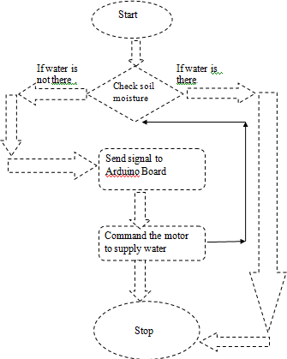

Figure 6.2

Flow chart

**6.3 Block Diagram:**

Firstly the data is transferred from the soil sensor to the micro controller i.e Arduino Uno Board then it analyze the signal sent by the soil sensor and accordingly command the relay board through which the water pump is connected then the water pump will act according to what signal was given by the soil sensor.



Figure 6.3 (11)

Block Diagram

**6.4 Circuit Diagram:**

Here is the circuit diagram in this diagram you can see the arduino board pins are connected to relay board and soil moisture sensors.a 5v pin is connected to the 4-relay board in vcc and GND is connected to the 4-relay board’s GND and IN1 of 4-relay board is connected to the input pins in arduino board.

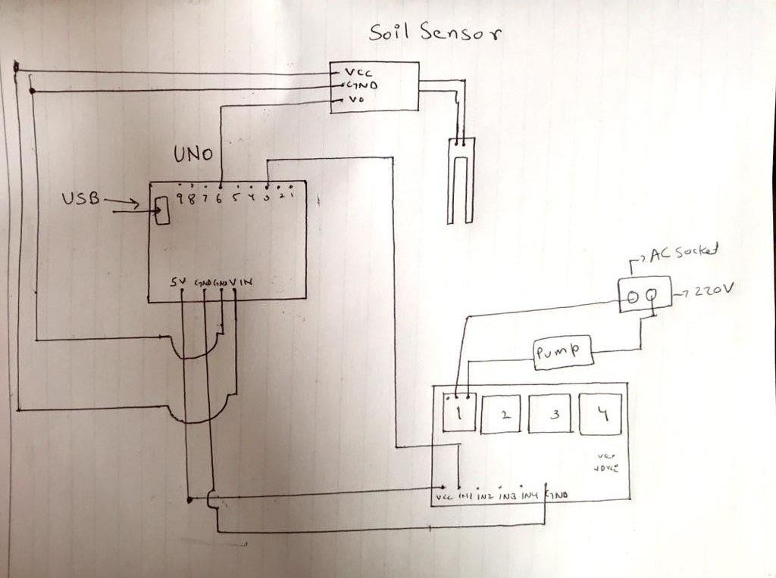

Figure 6.4

Circuit Diagram

# 6.5 System Requirements :

* + ArduinoBoard
  + Motor
  + A water Pump
  + Jumperwires(m/f)
  + Jumperwires(f/f)
  + SoilMoistureSensors
  + 4ChannelRelayBoard
  + Laptop

# Software Requirements:

* Arduino Platform1.8.6
* OperatingSystem:Windows10

**7.Prototype**

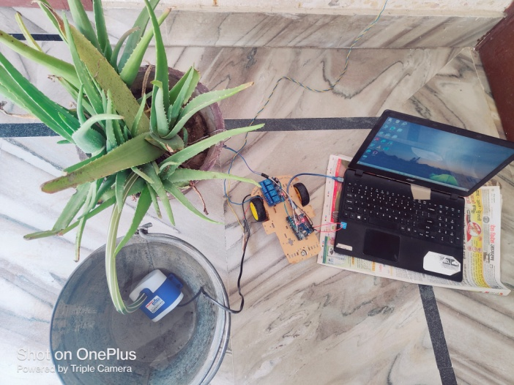

Picture 1

Setup of the system

In this picture we can see the setup of this system and the devices that are used.

We have connected these devices with each other and providing the power from the Ac circuit.

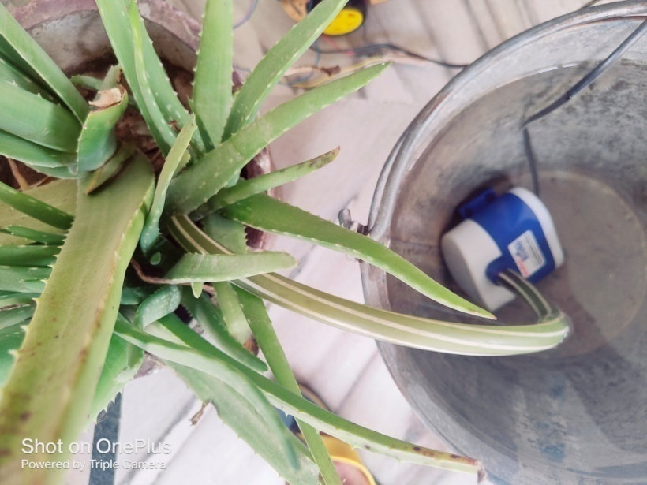

Picture 2

Water pump

In this picture we have connected a water motor pump to our 4-Relay Module and we are supplying electricity to it through a 220v socket and the pipe is connected to the plant.

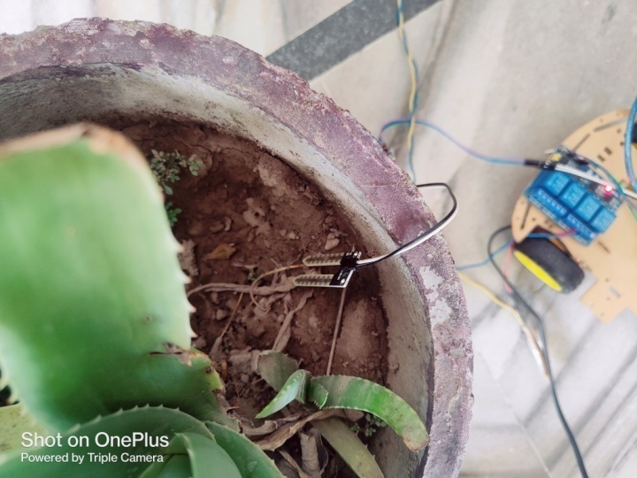

Picture 3

Soil moisture sensor

In this picture we can see the soil moisture sensor is in the pot and ready to send the signal to the arduino board,

Right now there is no moisture present in this soil, so according to our code arduino will command the 4-Relay board to start the water pump and supply the water in the pot. we have used jumper wires to connect these devices.

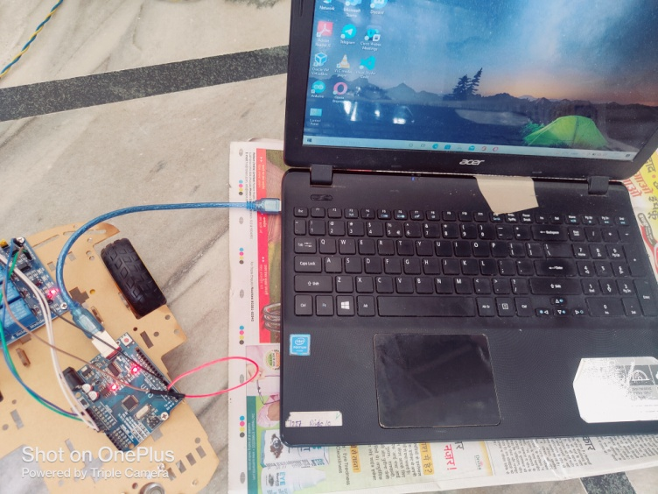

Picture 4

Arduino Board connected to laptop(for connectivity of power)

In this picture our arduino is connected to our laptop so that we can supply it power we are using HDMI cable

to supply the power we can also use a separate port that is only used to supply power to arduino. We have used this HDMI cable to upload the code into arduino from our laptop. The lights on the sensor and arduino blinks when any activity happen in this system i.e either the pump stops or starts.

**8.Arduino Platform Code**

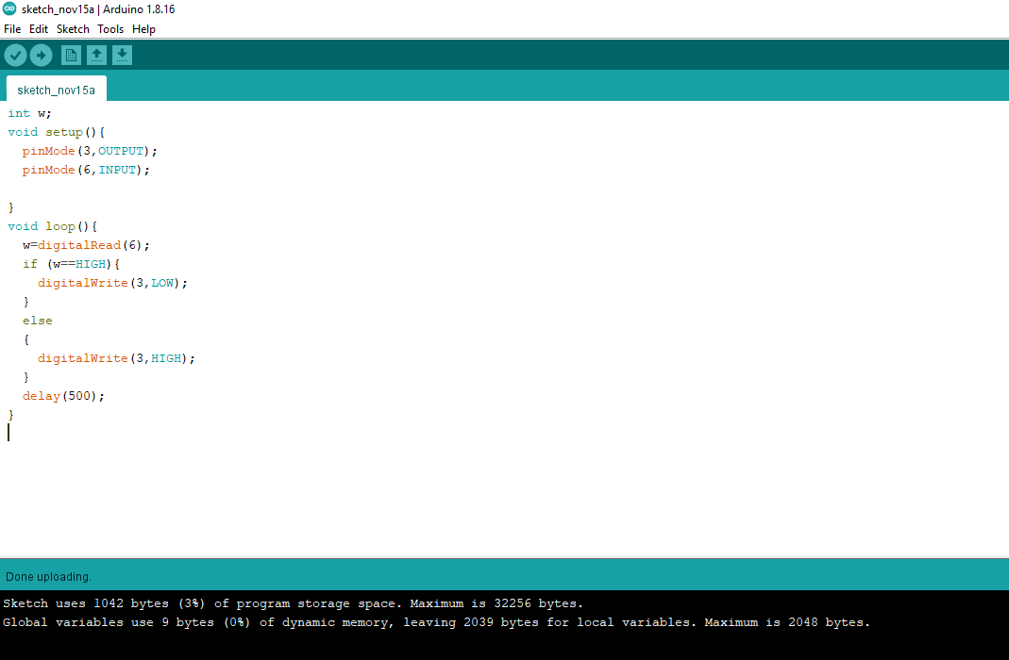

Picture 1

Arduino IDE Platform for coding

In this picture we can see the IDE platform that is being used in this project and the code is also written there .

After writing the code in this platform we need to go to the tool option from the taskbar above the code and when the dialog box will open we need to go to the boards option from the dropdown list and select the arduino uno board and then we have to go to the port option in the dropdown list and select the port which you are using ,after that we need to verify and compile the program by clicking the verify option from the taskbar, if the code is compiled without any error then you can click on upload option present in the taskbar.

int w;

void setup(){

pinMode(4,OUTPUT);

pinMode(7,INPUT);

* In this paragraph of code we have first initialized a variable “w” and then we have declared a function inside that function we have used pinMode keyword to declare the output pin i.e 4. This pin will send the signals to the 4-channel Relay board depending on the signal sent by this pin the board will decide whether to continue watering the plant or not ,now we have declared pin 7 as input pin it will take the input signal coming from the soil sensor and will take the input to the arduino board so that it can give an output signal through pin 4.

}

void loop()

{

w=digitalRead(7);

* Here in this line of code we have assigned the variable a task by using the inbuilt function from the arduino library we are telling the arduino to read the signals sent by the soil sensor through the INPUT pin 7.

if (w==HIGH)

* If the field or pot is full of water then we it will immediately break the supply of water this we will know by the above code line that whether the signal sent tells that the field is full or not if it is full we need to cut the water supply we have used LOW keyword to cut the supply of water.

{

digitalWrite(4,LOW);

}

else

{

digitalWrite(4,HIGH);

}

* If the above block does not execute that means that the field or pot is not full then this block will execute we have used HIGH keyword to continuously supply the water and signal, we are using the pin 4 the output pin that will tell the water pump to remain high, the signal we are sending to this is going through arduino to relay board and then to the water pump.

delay(600);

* Here we are using delay function to command the system after how much time the water should be supplied to in the filed. basically we are delaying the output so that the user can adjust the pipe at the last moment if he want to.

}

* In this project we have used the C programming language to code the program that will control and manage the full system and according to this code the devices will operate, in this system arduino is used as a microcontroller which holds the code in it and manages all the activities during the execution of the program.

# 7. Future Scope And Conclusion

# Future Scope

In future update we added more featues which will help farmer to remotely access the system like if they want to check the status of motor whether pump is on or off or they can also check the moisture of the soil on his or her phone .This will also reduce the wastage of water or minimize the human intervention in farming activities .We are going add water level sensor to make a check on the water level and let the user know which water level is good for the crop. We can also add weather sensor so that if there is any chance of rain it will tell the farmer so that they can wait for the rain and not irrigate the field with motor pump it will save water as well as electricity. We can also add a sensor to check the fertility of soil so that we can use the stats given by the sensor to know what resources should be provided to the crops and in what amount and the soil is good for which crop.

**Conclusion**

Scarcity of water is the major issue that no country wants to face in future. And as Agriculture is one of the most important sector that uses a large amount of water in India therefore various techniques should be implement in order to conserve water. Also because of rise of global warming there is a great need to save water for food production and consumption. Therefore, we have developed a smart irrigation system which helps people to conserve water without compromising human efforts and quality of food production. Keeping in mind the basic need for irrigation we have developed a IOT based irrigation system which automatically detects the need of water in soil and provide water to them without any wastage of water and without any human involvement. We also tried to surpass the old (traditional) way of irrigation system which is not that much efficient and effective and requires a lot of human intervention.

# REFERENCES

1. **jain, Ira.** Smart Farms? how AI can solve water wastage. *earth.org.* [Online] April 19, 2019. [Cited: March 31, 2022.] https://earth.org/smart-farms-how-ai-can-solve-water-wastage-%EF%BB%BF/.

2. **Amazon.** Electronics. *Amazon.in.* [Online] Amazon. [Cited: March 31, 2022.] https://www.amazon.in/Elego-Complete-Starter-Arduino-Mega2560/dp/B01CZTLHGE. 2.

3. *Water Scarcity and security in India.* **G.Hedge, Dr.Narayan.** Pune : BAIF Deelopment Research Foundation. 3.

4. **mart, iIndia.** *Soil Moisture Sensor.* Mumbai : MICRON, 2003. 4.

5. **Salvithal, Nikhil N.** *Smart irrigation System Using iot.* Solapur : SVERI's college of engineering. 5.

6. **Priyadharsnee.K, Dr. S. Rathi.** *An IOT Based Smart Irrigation System.* coimbatore : Govt. college of engineerig, 2017. 6.

7. **V, Aswini B.** *A Study on Smart Irrigation System Using IoT for Surveillance of Crop-Field.* Banglore : International Journal of Engineering & Technology. 7.

8. **Products, Arduino.** Arduino older boards. *arduino.cc.* [Online] Arduino. [Cited: April 4, 2022.] https://www.arduino.cc/en/main/boards. 8.

9. **Mybotic.** *mybotic.com.* [online] dehradun : mybotic, 2022. 9.

10. **Sunfounder.** sunfounder.cc. *sunfounder.com.* [Online] sunfounder. [Cited: April 4, 2022.] http://wiki.sunfounder.cc/index.php?title=4_Channel_5V_Relay_Module. 10.

11. **S Nalini Durga, M RamaKrishna.** *SMART IRRIGATION SYSTEM BASED ON SOIL MOISTURE USING IOT.* Tirupathi, Andhra Pradesh : IRJet, 2018. 11.

**Draftverifiedby**

### Project Guide

### (Dept .of Cybernetics)

### Asst. Professor

### Dr. Rohit Srivastava

### Signature: